**CinemaTick: Smart Event Ticketing System**

Summary Report

**Project Overview**

CinemaTick is an innovative, full-stack event ticketing system that enables users to seamlessly browse events, book tickets with real-time seat selection, and receive booking confirmations via email with QR codes. Admin users can manage events and oversee bookings efficiently. The system is powered by a graph database (Neo4j), with a FastAPI backend and Streamlit frontend, ensuring real-time interaction, reliability, and scalability.

**Architecture & Technology Stack**

|  |  |
| --- | --- |
| **Layer** | **Technology Used** |
| Front-end | Streamlit (Python-based Web UI) |
| Back-end | FastAPI (Python REST API Framework) |
| Database | Neo4j (Graph Database) |
| Email Service | SendGrid API, QR Code Generation |

Supporting Libraries - requests, qrcode, Pillow, uvicorn, streamlit.

**System Design**

**(Front-end) Streamlit**

* **Homepage:** Displays welcome message and event categories.
* **User Login/Register:** Simple authentication mechanism differentiating users and admins.
* **Browse Events:** Users can browse and filter events by category.
* **Seat Selection:** Interactive seat layout (VIP and Standard rows).
* **Booking Management:** View, confirm, or cancel bookings.
* **Admin Dashboard:** Create events, edit event details, view and manage bookings.

**(Back-end) FastAPI**

* **Authentication Endpoints:** /register, /login
* **Event Management:** /events, /add-event, /update-event, /event/{event_name}
* **Booking Management:** /book, /cancel, /bookings/{user_email}
* **Seat Management:** /booked-seats/{event_name}
* **User Management:** /users

**(Database) Neo4j**

**Nodes:** User, Event, Venue, Category

**Relationships:**

(:User)-[:BOOKED]->(:Event)

(:Event)-[:HELD_AT]->(:Venue)

(:Event)-[:BELONGS_TO]->(:Category)

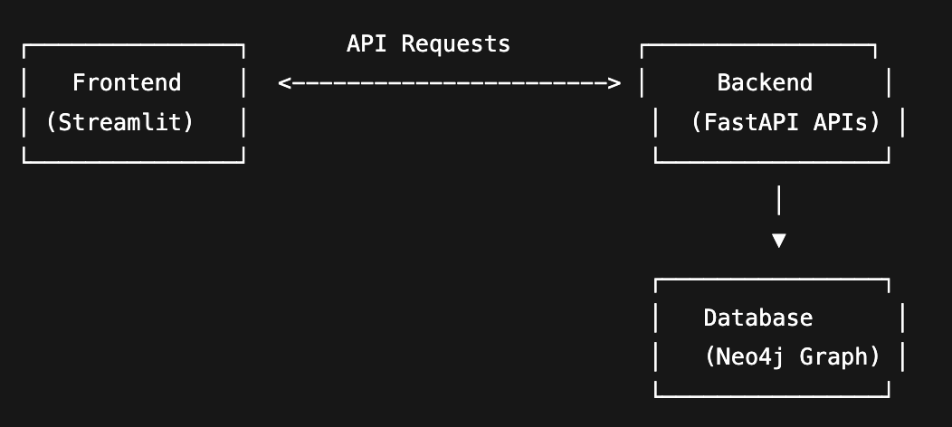

**Figure1: Overall Architecture**

Sample Booking Relationship:  
**(u:User)-[:BOOKED {booking_id, seats, seat_info, date}]->(e:Event)**

**Email Confirmation System**

* Upon successful booking, users receive a confirmation email with:
* Event details
* Booked seats
* A QR code attachment encoding booking information
* Upon booking cancellation, a cancellation confirmation email is sent.

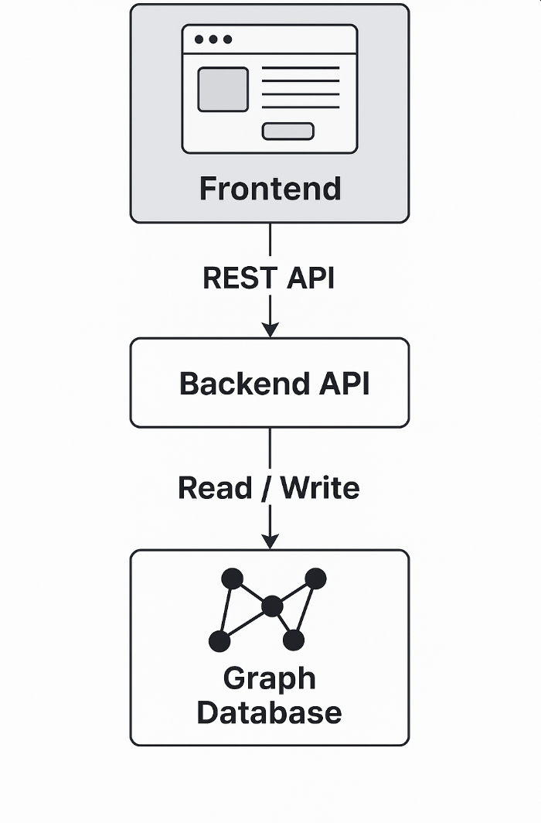

**Figure2: Visual representation of frontend-to-backend-to-database interaction**

**Application Functionalities**

**User Side**

* Register/Login with email and password.
* View Events with details: venue, date, time, seat availability, VIP/Standard prices.
* Real-time Seat Booking with dynamic seat availability.
* Receive Booking Confirmation Email with QR code.

**Admin Side**

* Add New Events.
* Edit Existing Events.
* View All Users and their Bookings.
* Cancel User Bookings.

**Setup & Installation**

**Back-end Setup**

pip install -r requirements.txt

uvicorn main_cleaned:app --reload

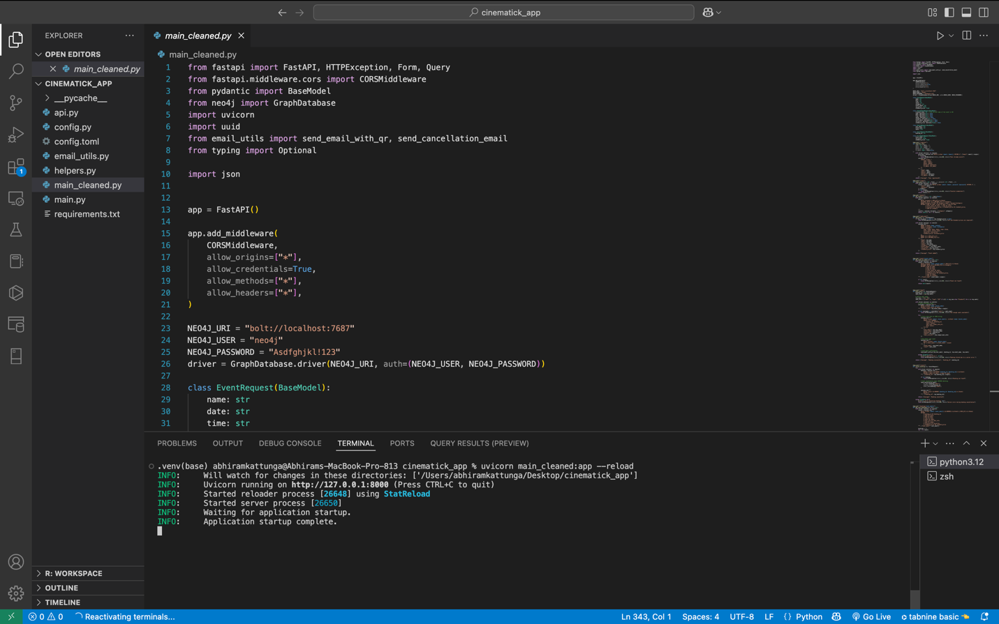

**Figure3: Back-end running**

**Front-end Setup**

streamlit run main.py

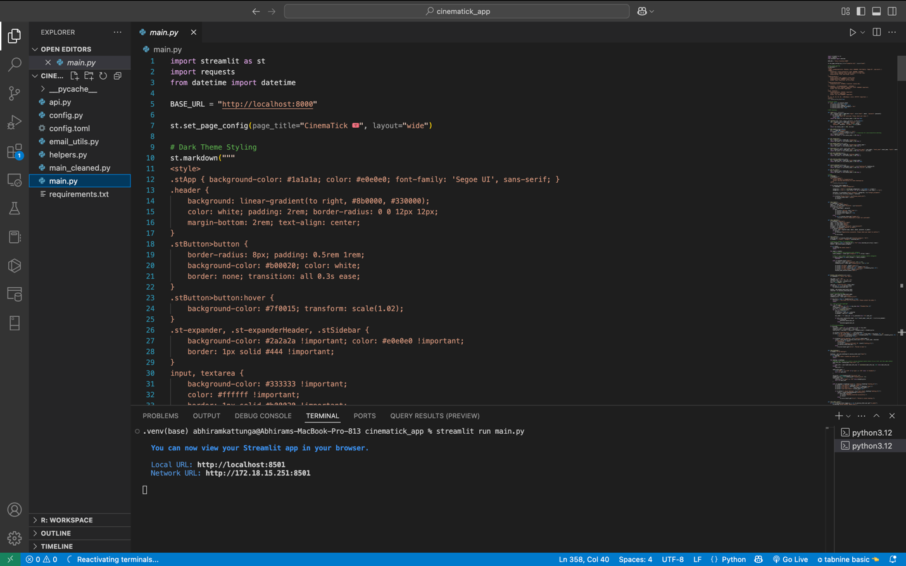

**Fgiure4: Front-end running**

**Database Setup**

Install Neo4j Desktop or use Neo4j Aura.

Connect FastAPI to Neo4j (bolt://localhost:7687).

**Screenshots & Evidence**

* Frontend Interface:
* Login and Register pages.

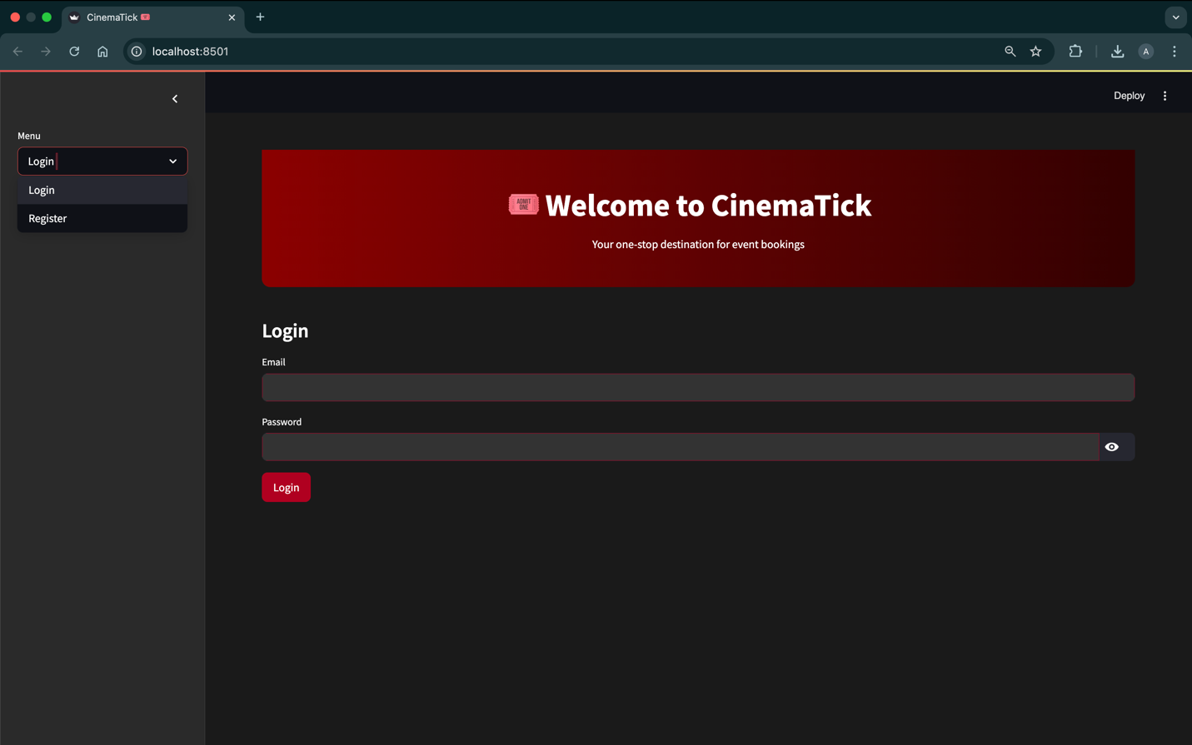

**Figure5: Login and Registration**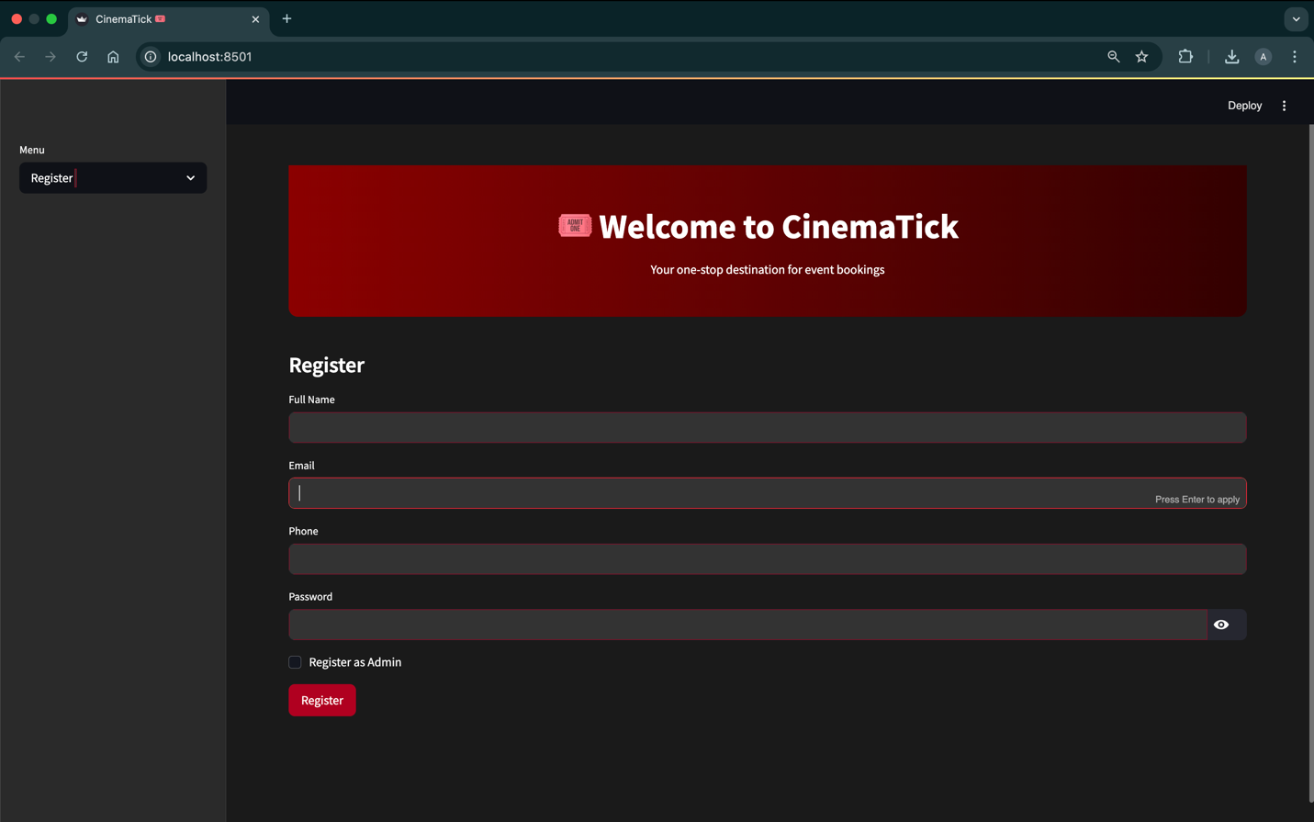

**Figure6: Registration of a User/Admin**

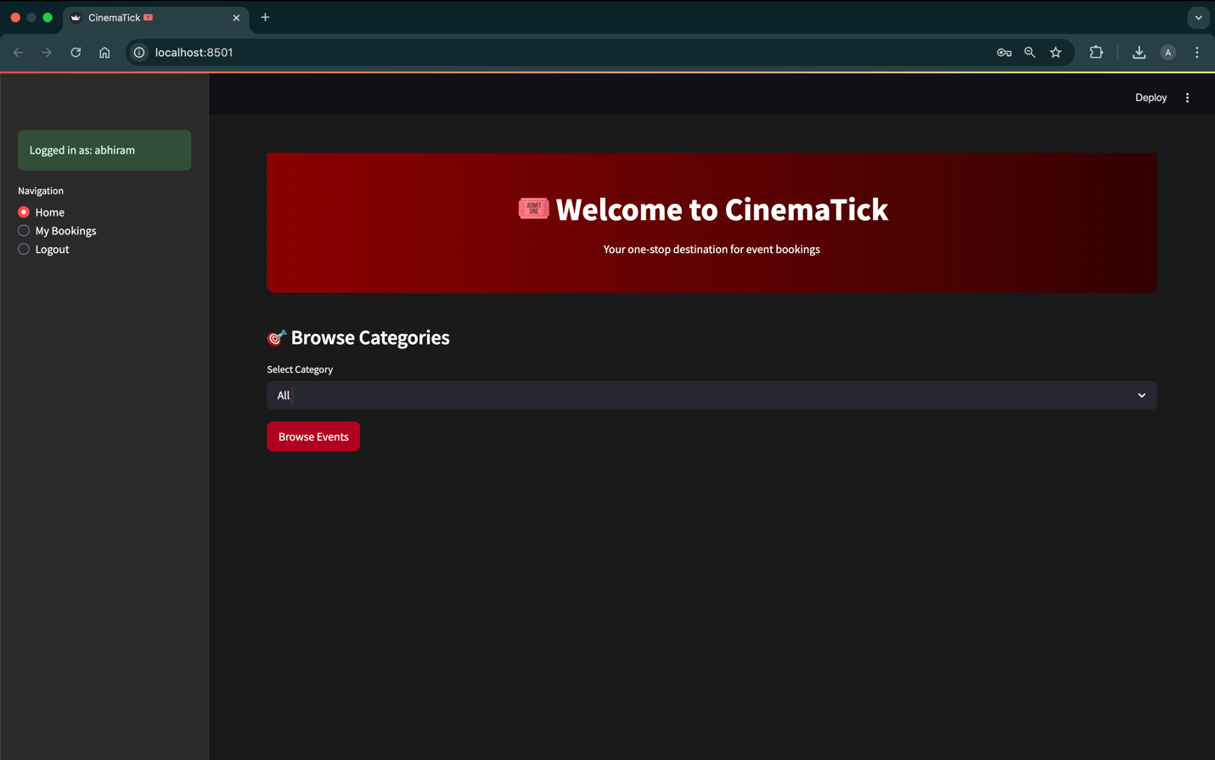

**Figure7: Homepage**

* Event browsing and seat selection.

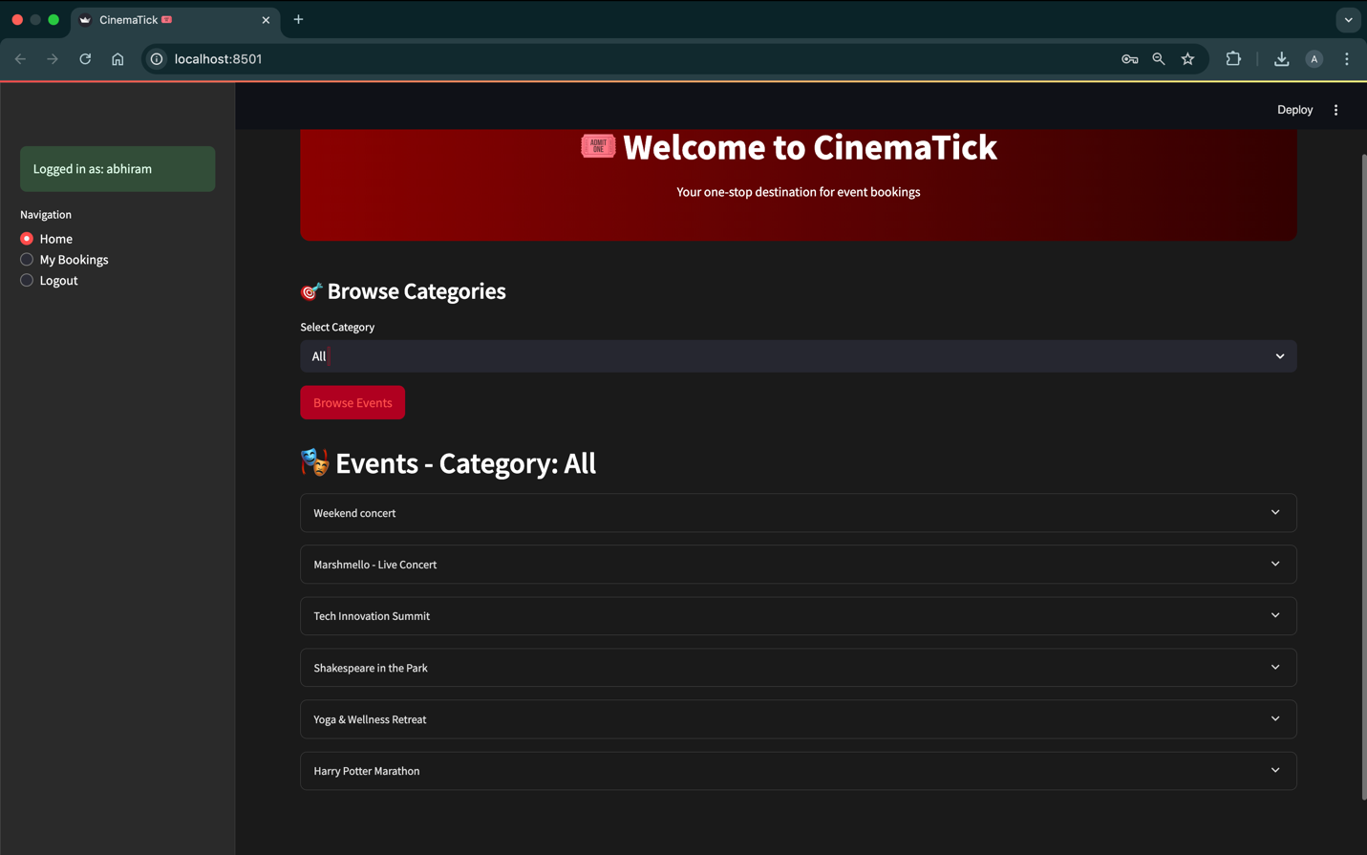

**Figure8: Browse Events**

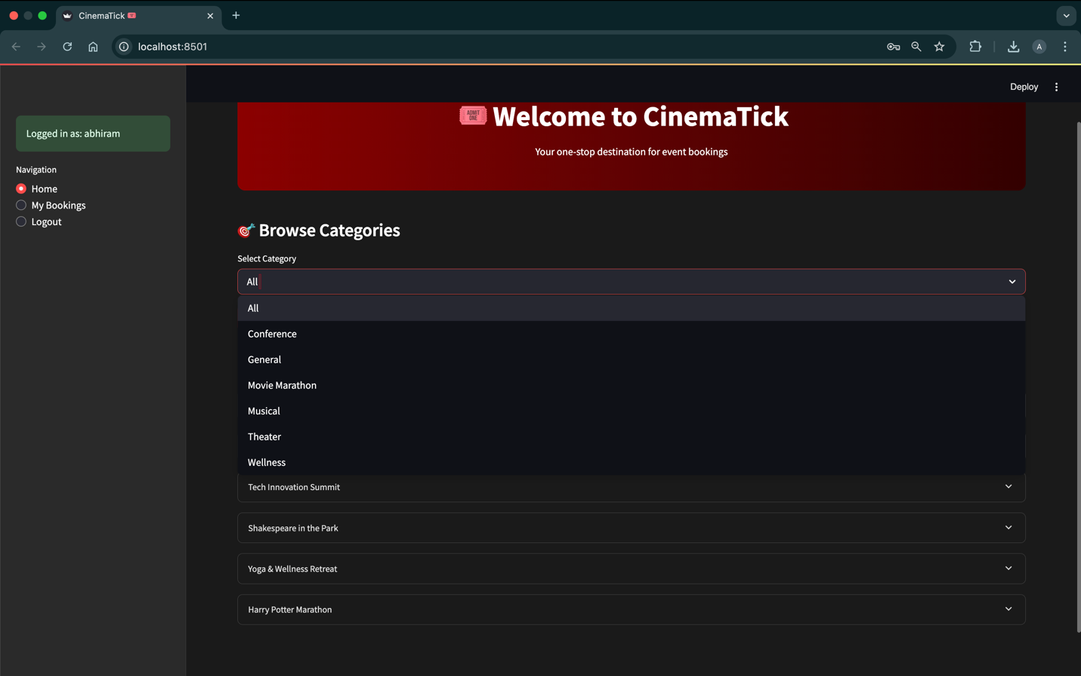

**Figure9: Event Categories**

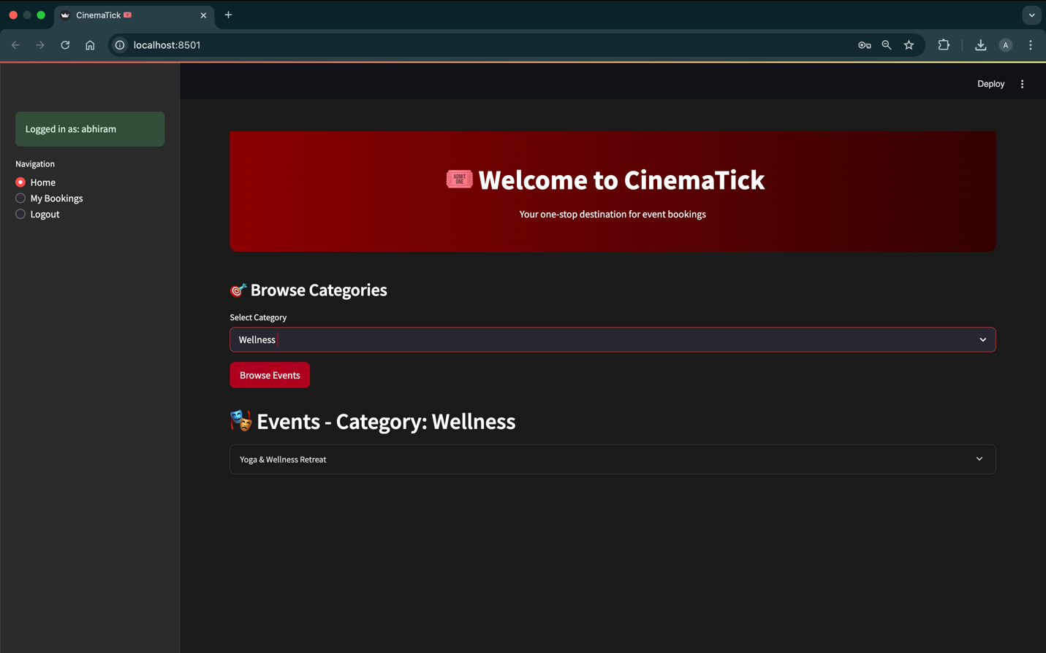

**Figure10: Category specific Events display**

* My Bookings

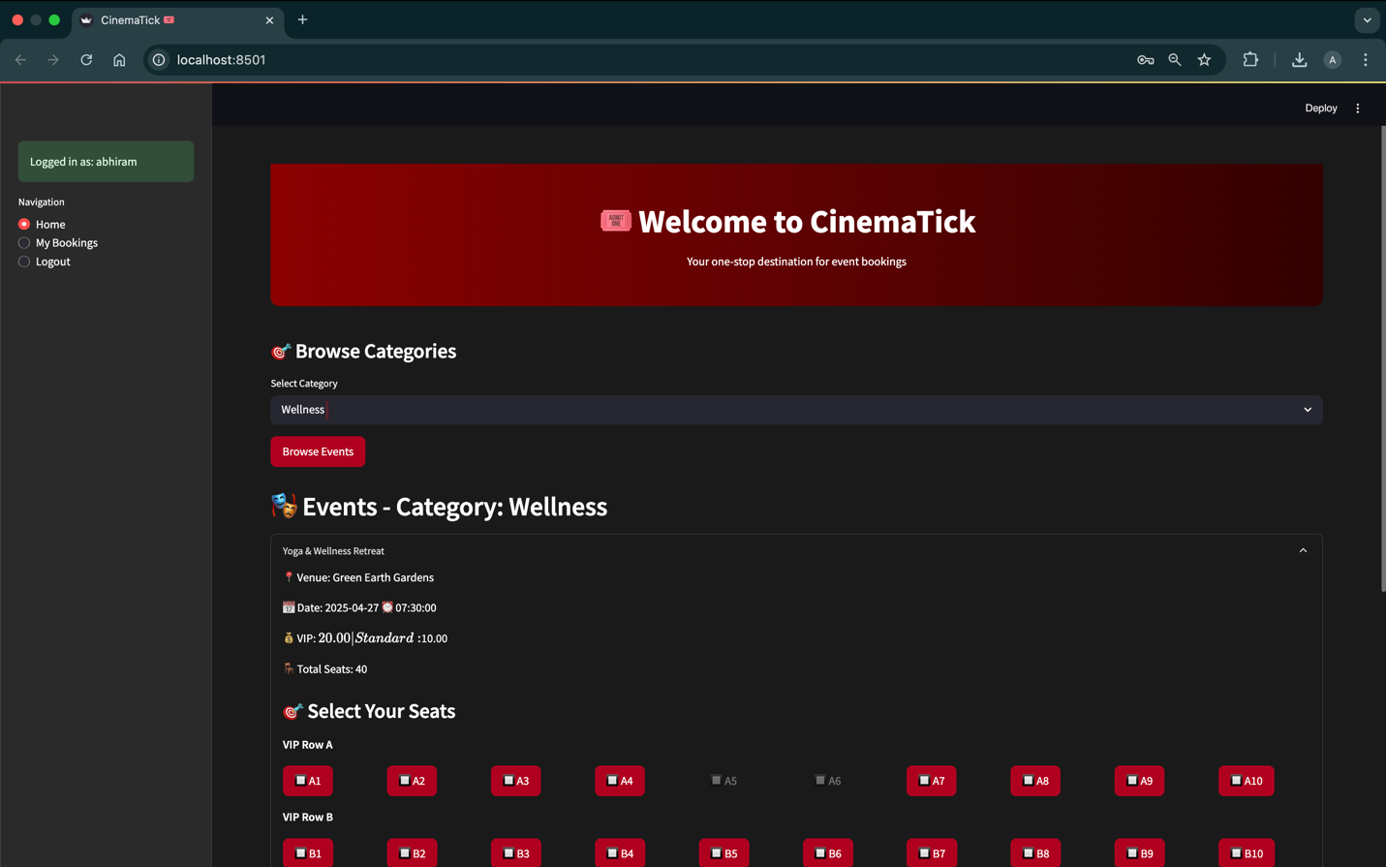

**Figure11: Event Booking**

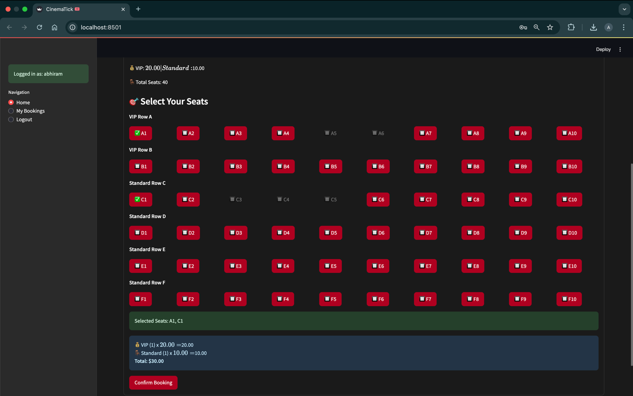

**Figure12: Graphical Seat Selector (VIP/Standard seats and corresponding prices)**

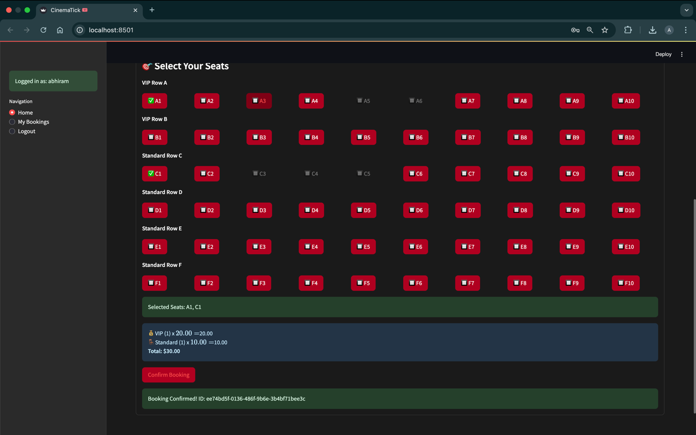

**Figure13: Confirmation of booking**

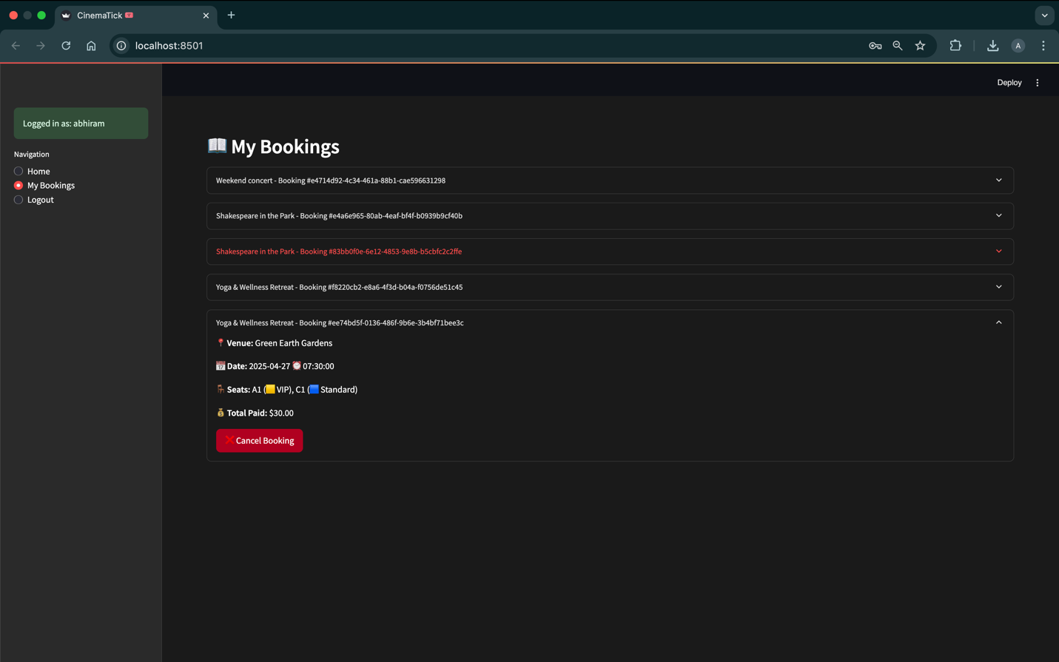

**Figure14: ‘My Bookings’ and latest booking confirmation**

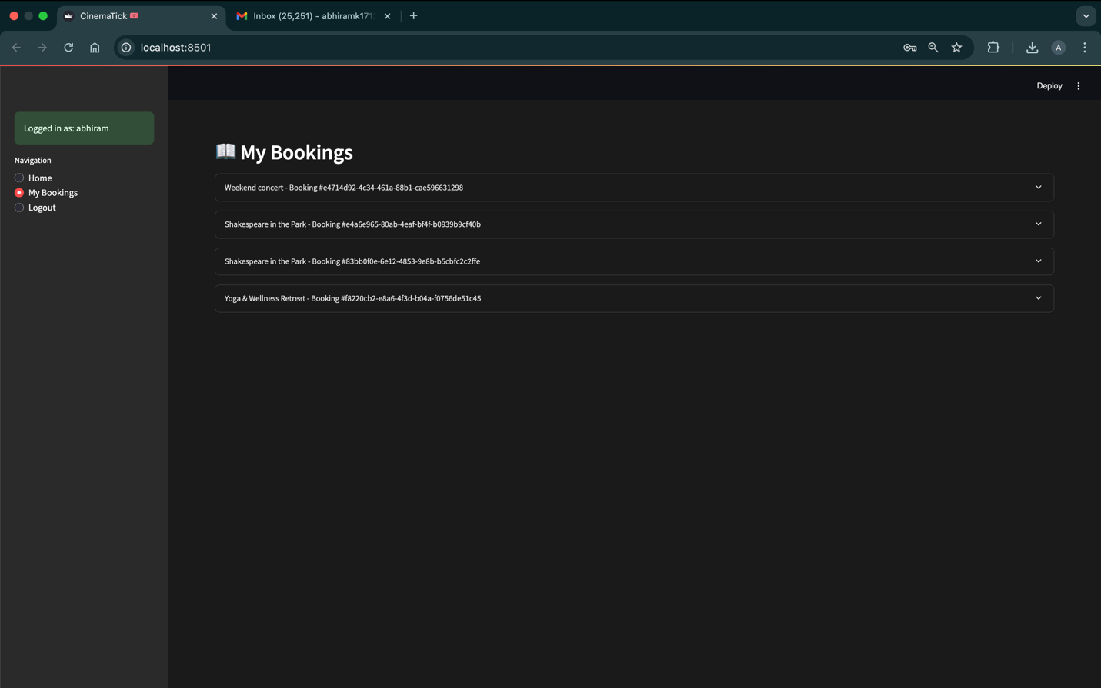

**Figure15: My Bookings**

* Admin Panel

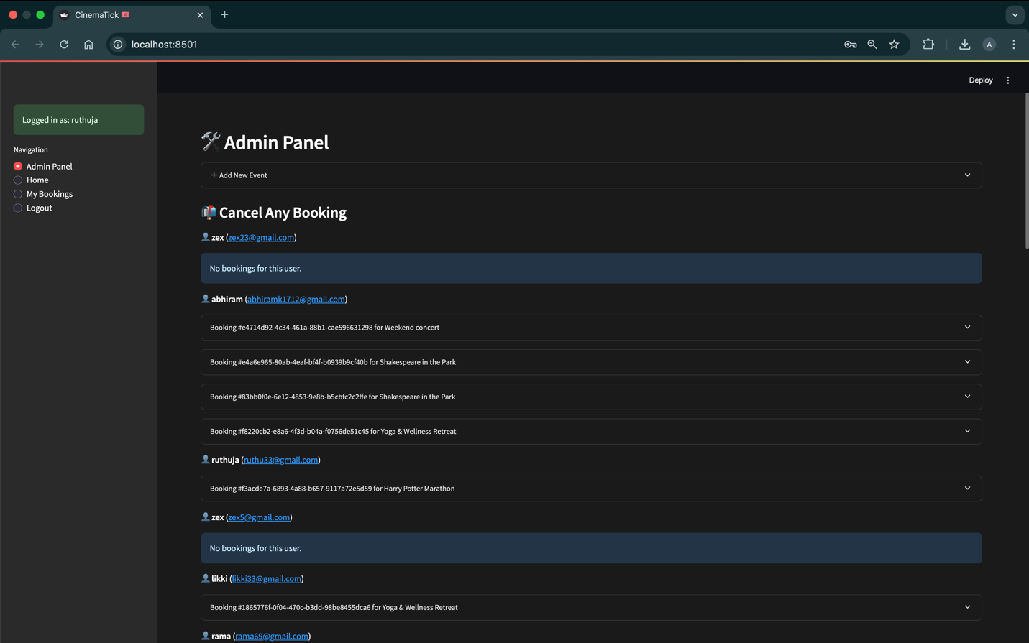

**Figure16: Admin Panel (User’s bookings)**

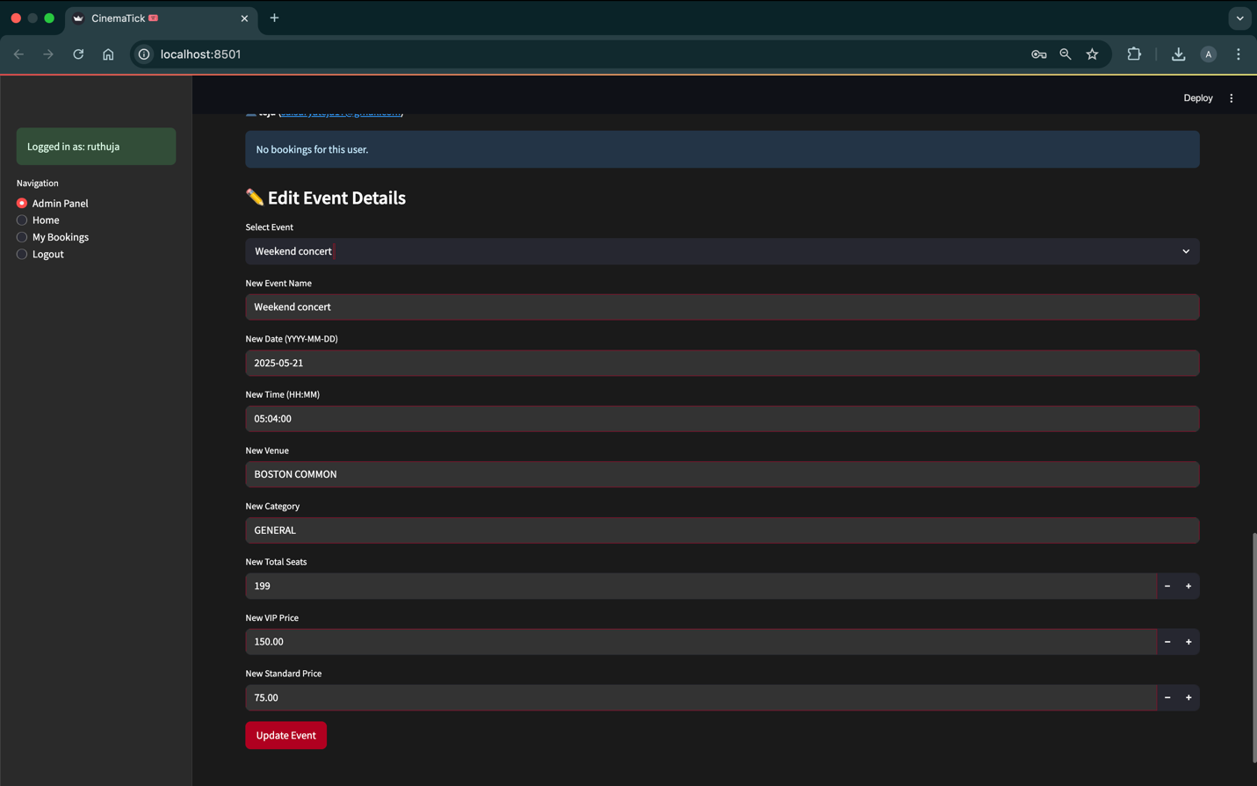

**Figure17: Event Update Panel**

* Backend API (FastAPI Swagger Documentation):
* /register, /login, /book, /cancel, /add-event APIs displayed.

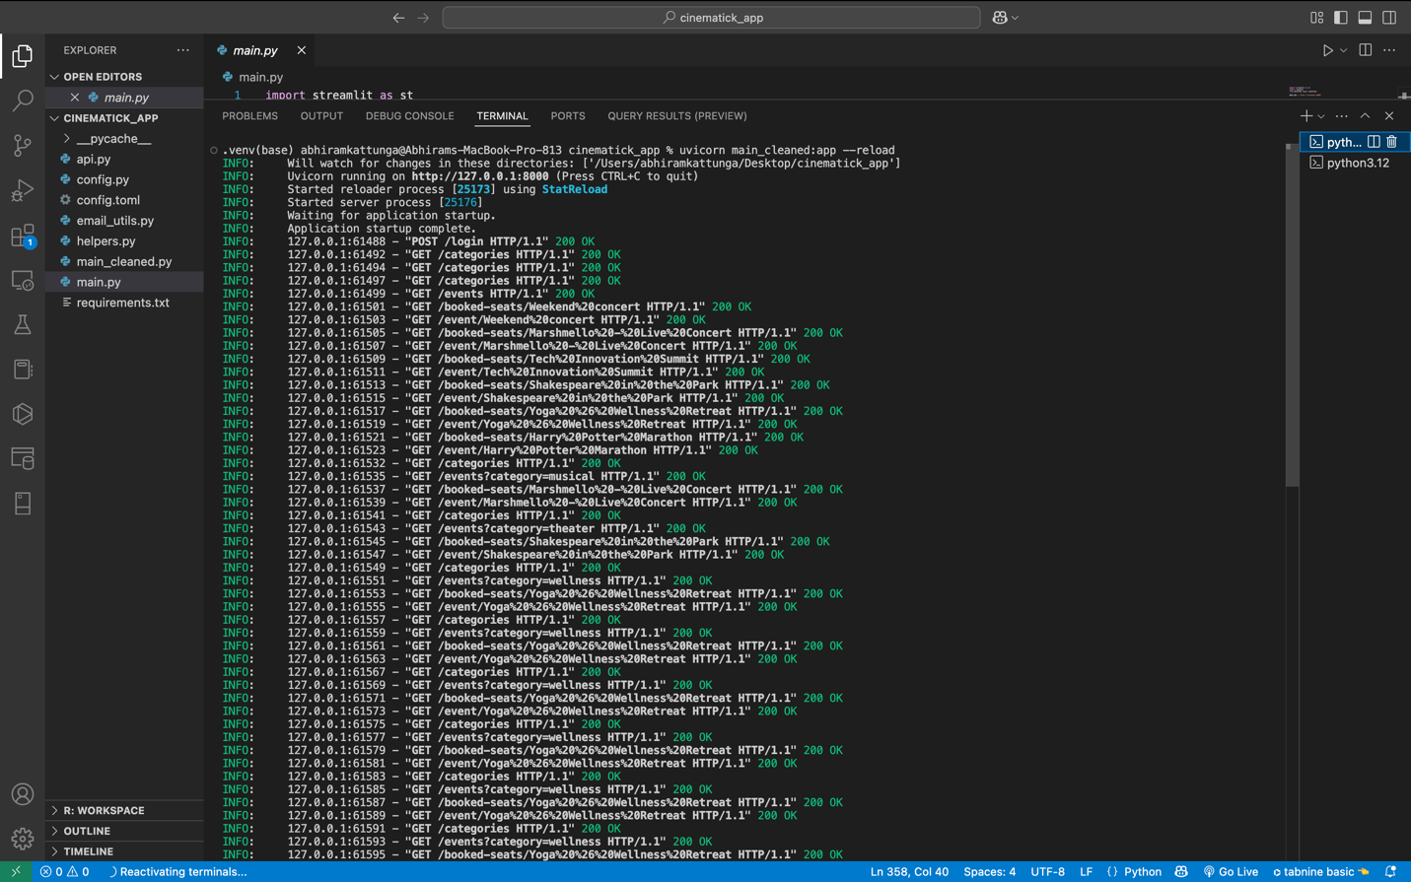

**Figure18: API running**

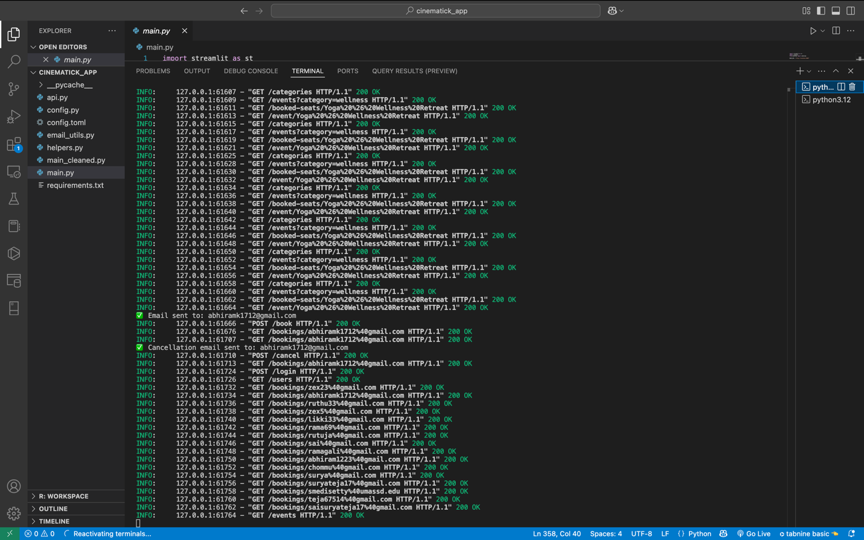

**Figure19: API running**

* Database (Neo4j Browser Screenshots):
* Graph visualization showing Users, Events, Venues, and Booked relationships.

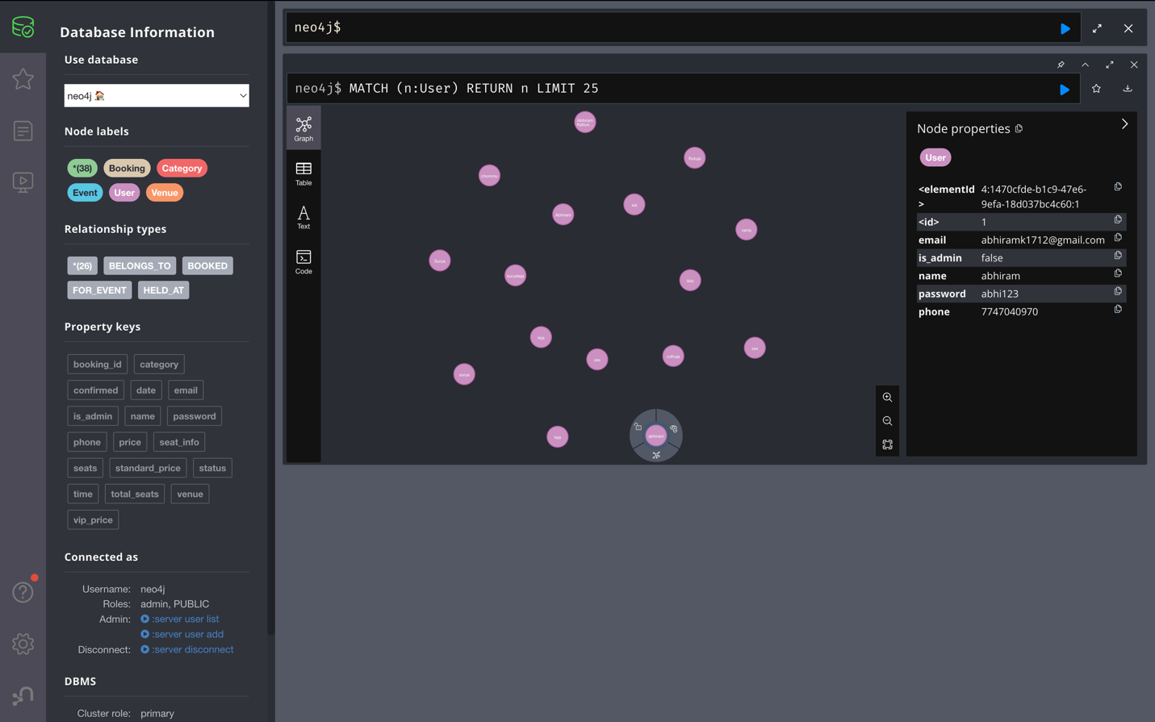

**Figure20: All users**

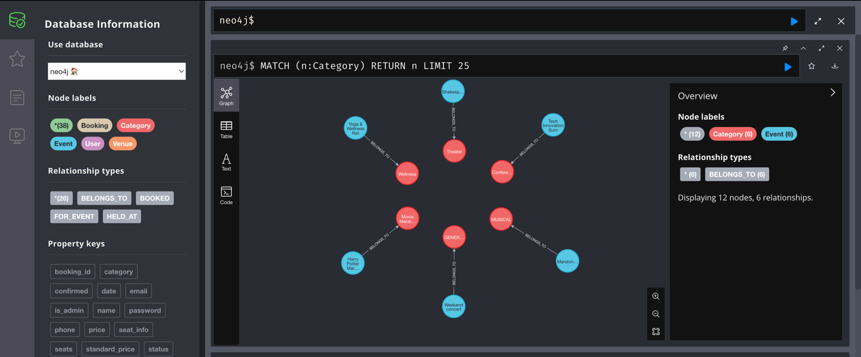

**Figure21: All Categories**

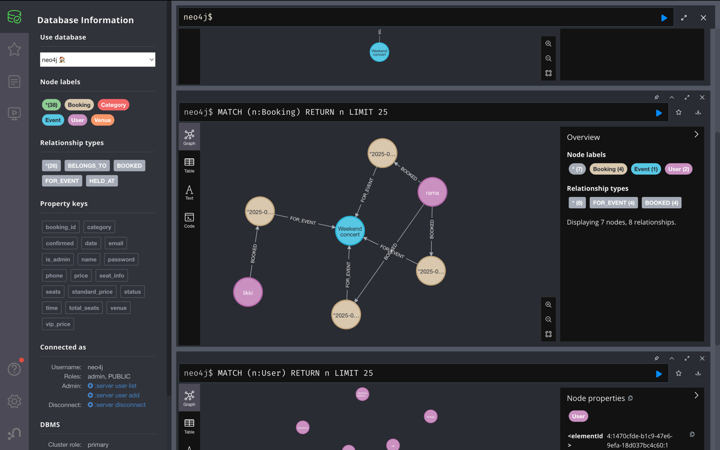

**Figure22: Bookings for an event**

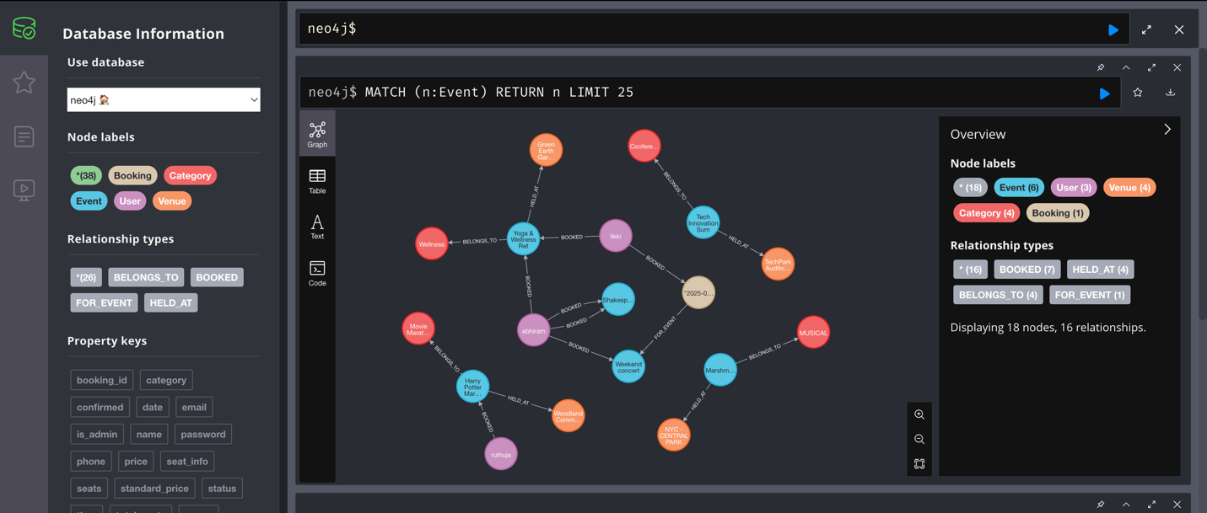

**Figure23: Connection of Events, Users, Venues, Categories, Events, and Bookings**

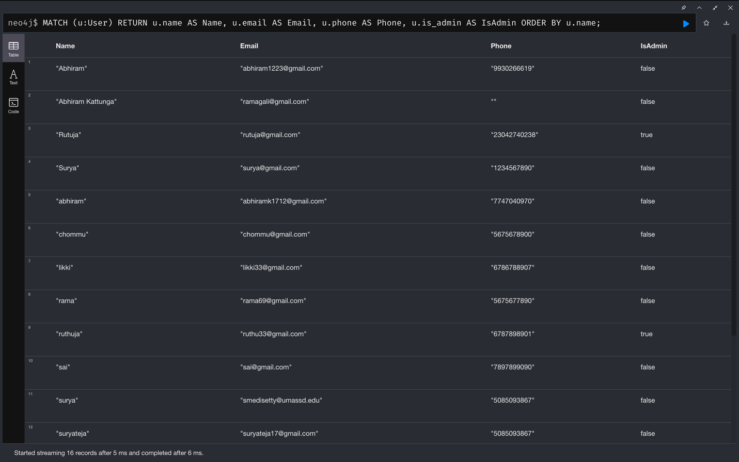

**Figure24: View All Users with Details**

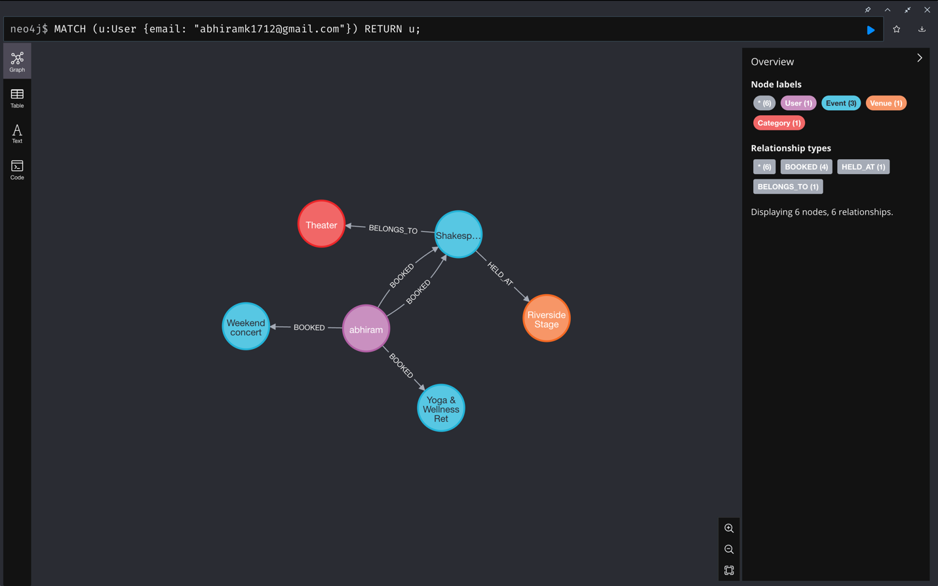

**Figure25: View Specific User by Email**

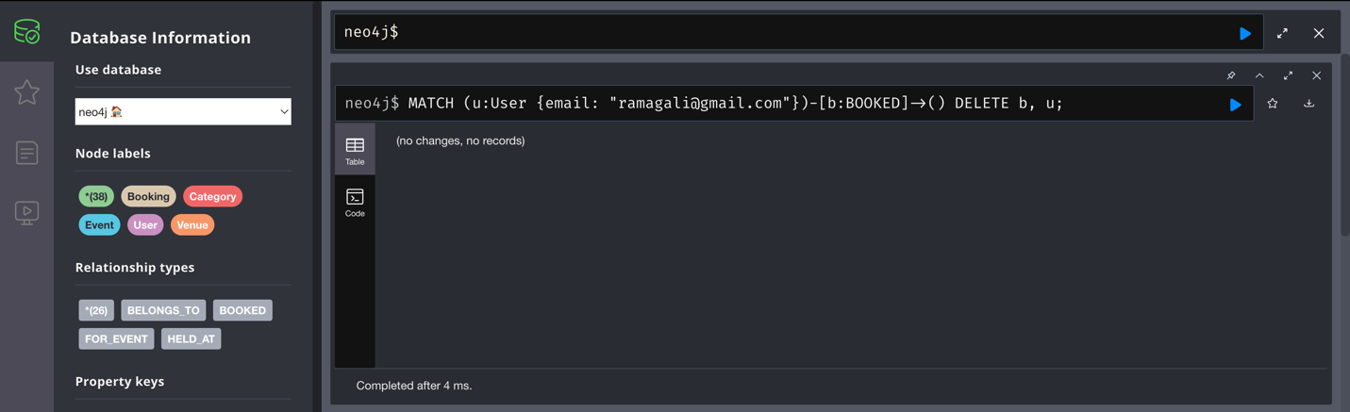

**Figure26: Delete a User (and their bookings)**

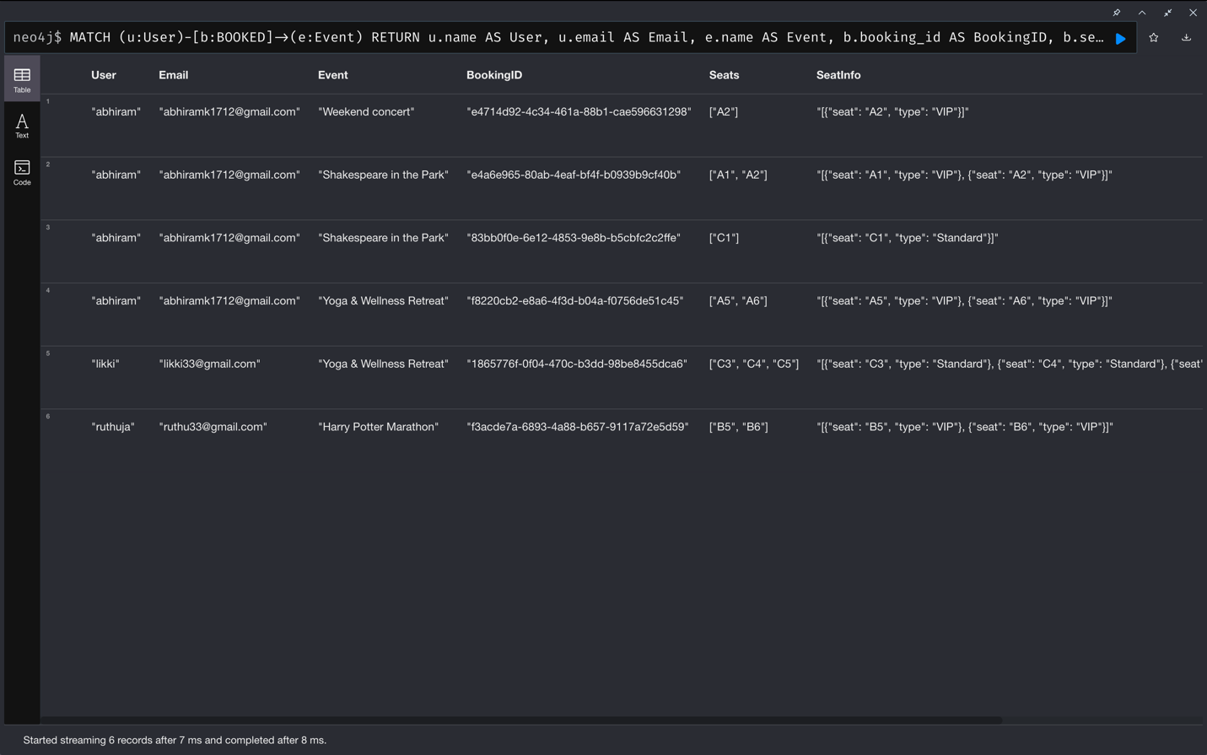

**Figure27: View All Bookings**

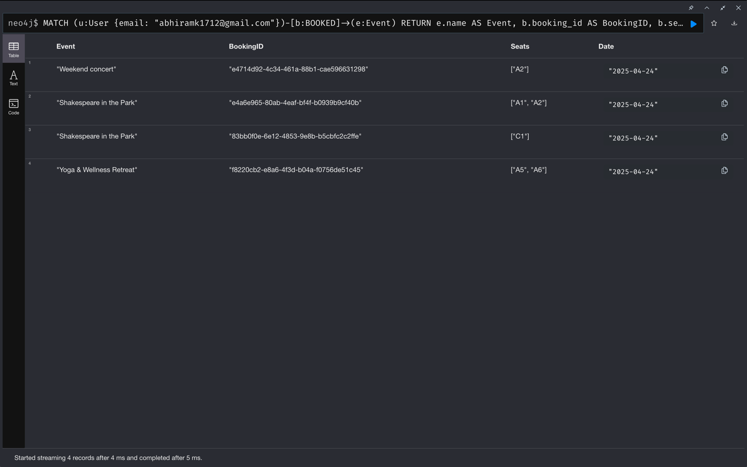

**Figure28: View Bookings by User Email**

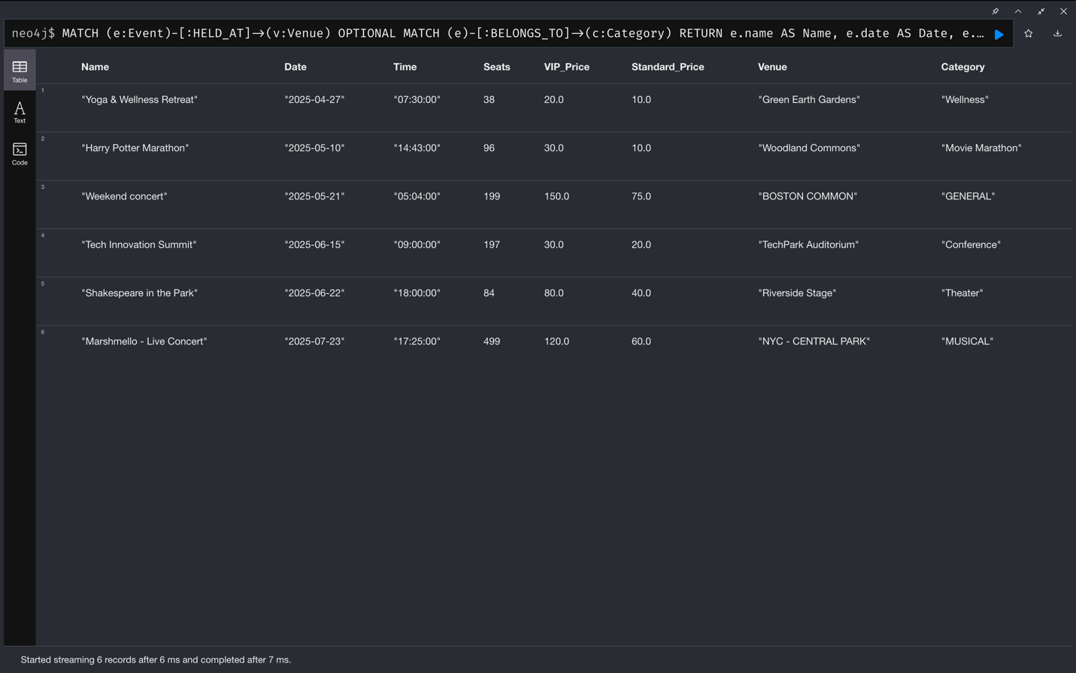

**Figure29: View All Events with Details**

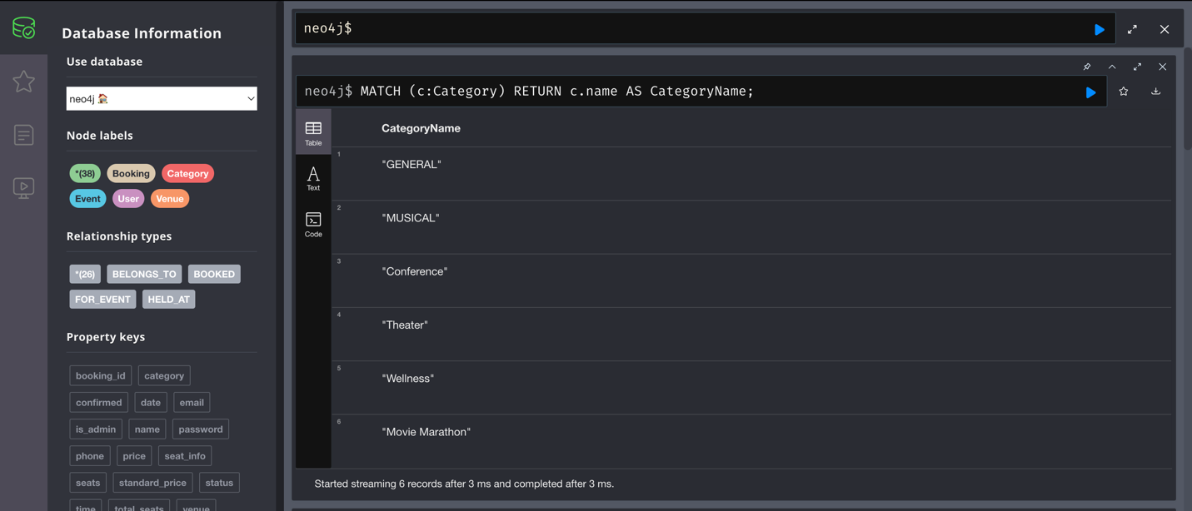

**Figure30: View All Categories**

* Email Confirmations:
* Sample Booking Confirmation Email with attached QR code.

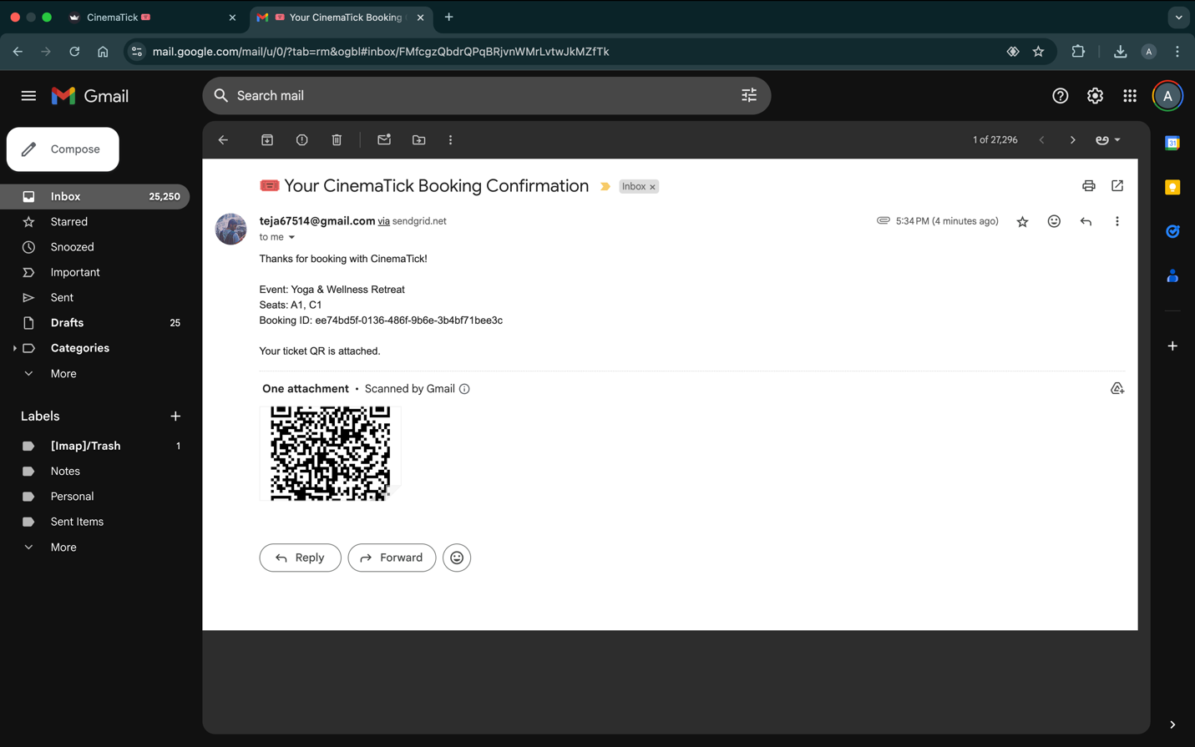

**Figure31: Email confirmation for latest Confirmed Booking**

* Sample Booking Cancellation Email.

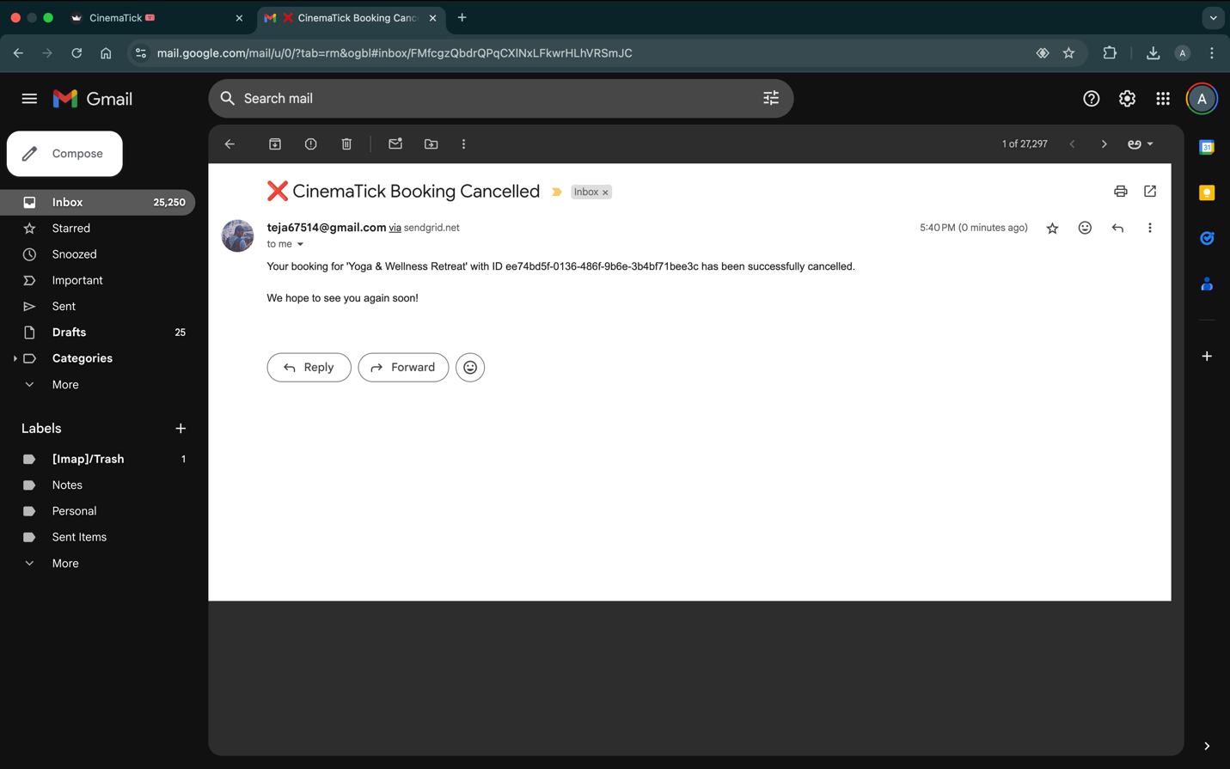

**Figure32: Email Confirmation for Booking Cancellation**

* Code Explanation:
* Excerpts from main_cleaned.py, helpers.py, email_utils.py showing key functionalities.

**Main_cleaned.py (Back-end)**

This FastAPI-based application interfaces with a Neo4j graph database, using a relationship-oriented schema to manage users, events, venues, categories, and bookings for an event ticketing system. The underlying database design follows a node-relation model, where entities such as User, Event, Venue, and Category are modeled as nodes, and interactions like bookings and classifications are modeled as relationships.

Each User node contains attributes like name, email, phone, password, and is_admin. When a user books tickets for an event, a BOOKED relationship is created from the User node to an Event node. This relationship carries detailed properties such as booking_id, seats, seat_info (which distinguishes VIP and Standard), and date, capturing transactional context. Events are modeled as Event nodes with attributes including name, date, time, total_seats, vip_price, and standard_price. These events are linked to Venue and Category nodes through HELD_AT and BELONGS_TO relationships respectively, promoting modularity and reusability of venue and category data.

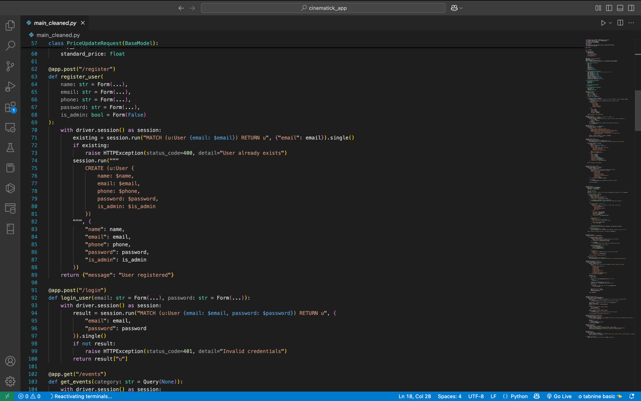

The backend routes implement standard CRUD functionality for user registration and login, adding and updating events, seat booking with availability validation, event querying, and category/user listings. Upon successful booking, a seat count is decremented on the Event node to reflect real-time availability. Email notifications (including QR codes) are also triggered on bookings and cancellations.

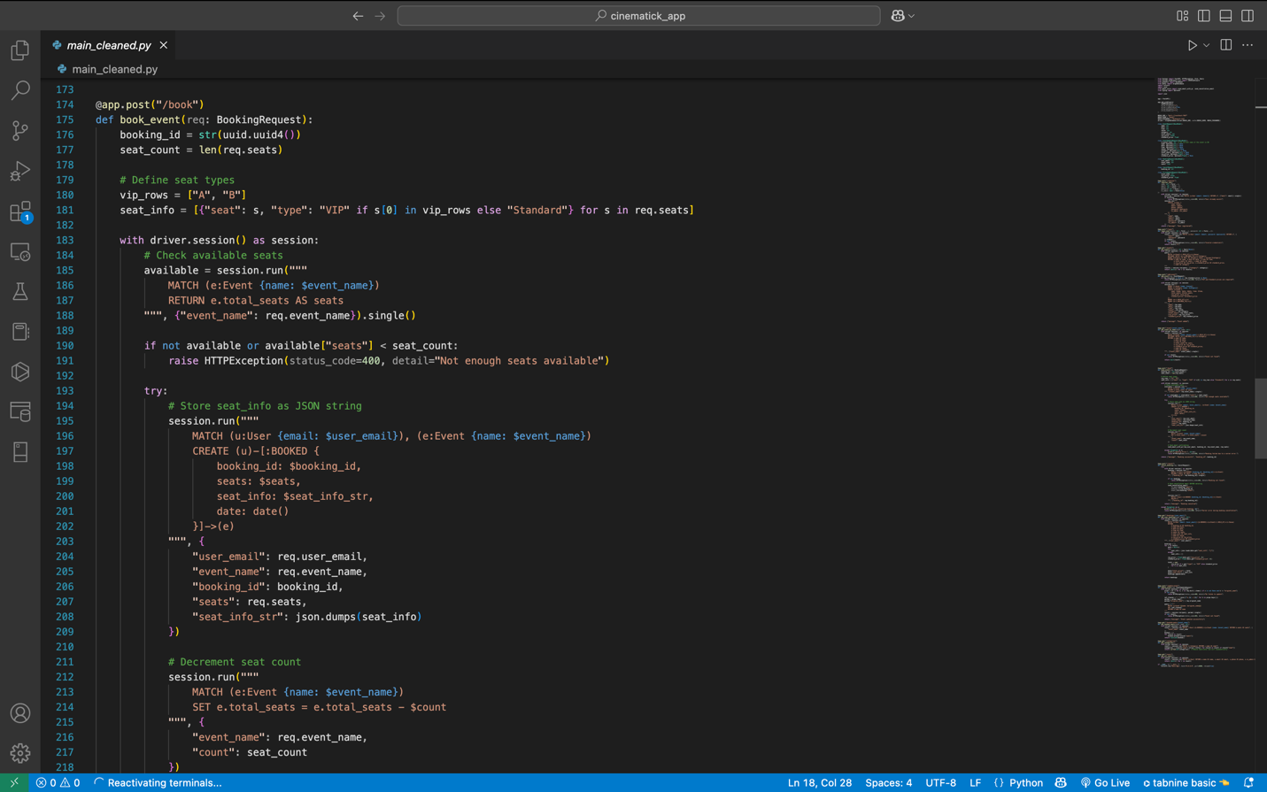

This graph-based design allows for highly efficient traversal and relationship-based queries, such as finding all bookings by a user, checking all events at a venue, or categorizing events. It is well-suited for systems with rich interconnections, enabling real-time seat validation and fast lookup of related entities—tasks that are typically slower in traditional relational databases due to JOIN overhead.

**main.py (Front-end)**

This Streamlit-based frontend for CinemaTick is a dynamic web interface that interacts with the backend FastAPI server and, indirectly, with the Neo4j graph database. Although this frontend does not directly manipulate the database, it acts as a bridge between the user and the underlying Neo4j database, ensuring that all user actions—such as registration, login, seat booking, and event management—are reflected appropriately in the graph database through REST API calls.

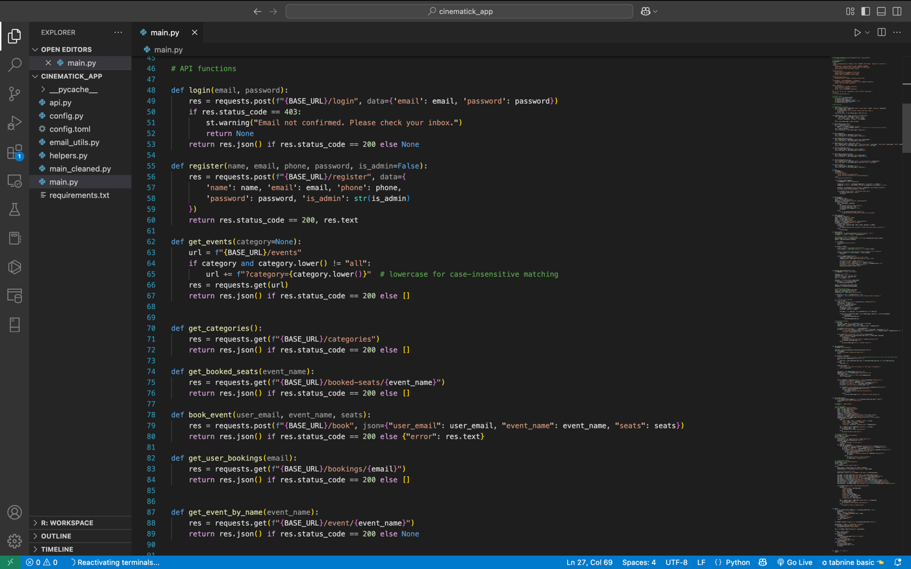

The frontend handles user authentication (registration and login) by communicating with /register and /login backend APIs. User and event information is stored in Neo4j nodes and booking actions (seat selections) create BOOKED relationships between User and Event nodes. When users browse events or select seats, the Streamlit app fetches data from the database (via the backend APIs) like available events, event categories, and currently booked seats. During booking, the frontend sends selected seat information, and the backend processes it to create relationships and update seat availability directly in Neo4j. Similarly, viewing or cancelling bookings interacts with the BOOKED relationship records stored in the graph database.

For administrative operations, the admin panel in Streamlit enables creation, modification, and cancellation of events and bookings. These admin actions trigger backend updates that create or modify Event, Venue, and Category nodes and their relationships, ensuring the graph database remains consistent.

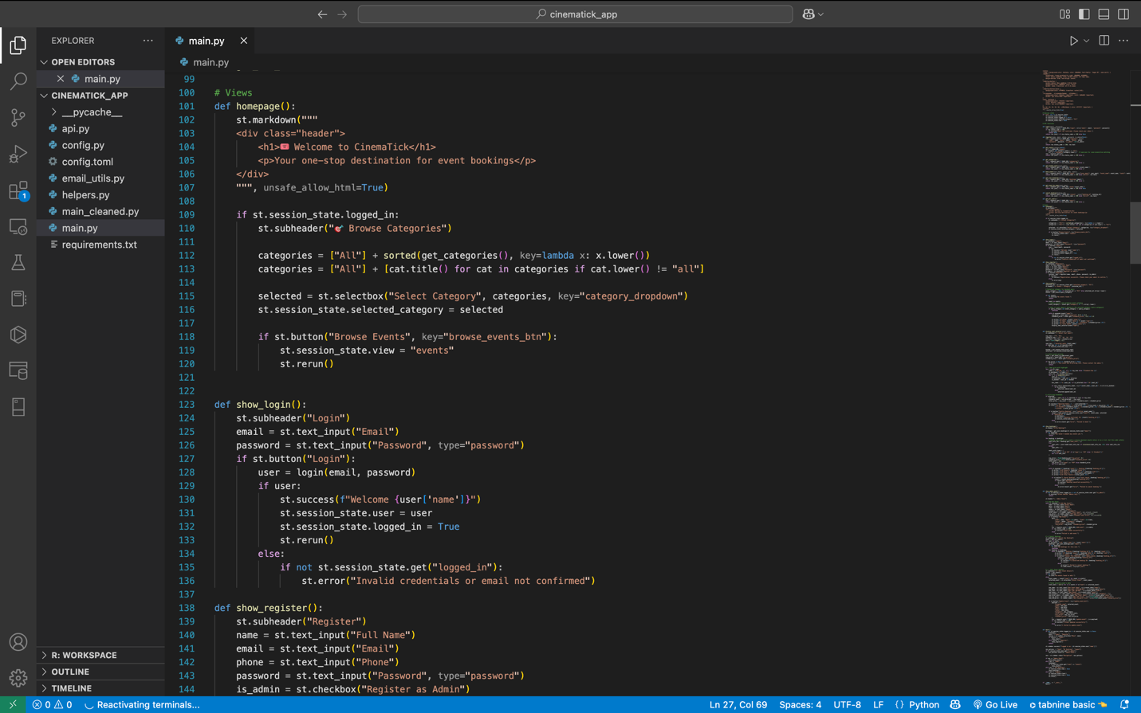

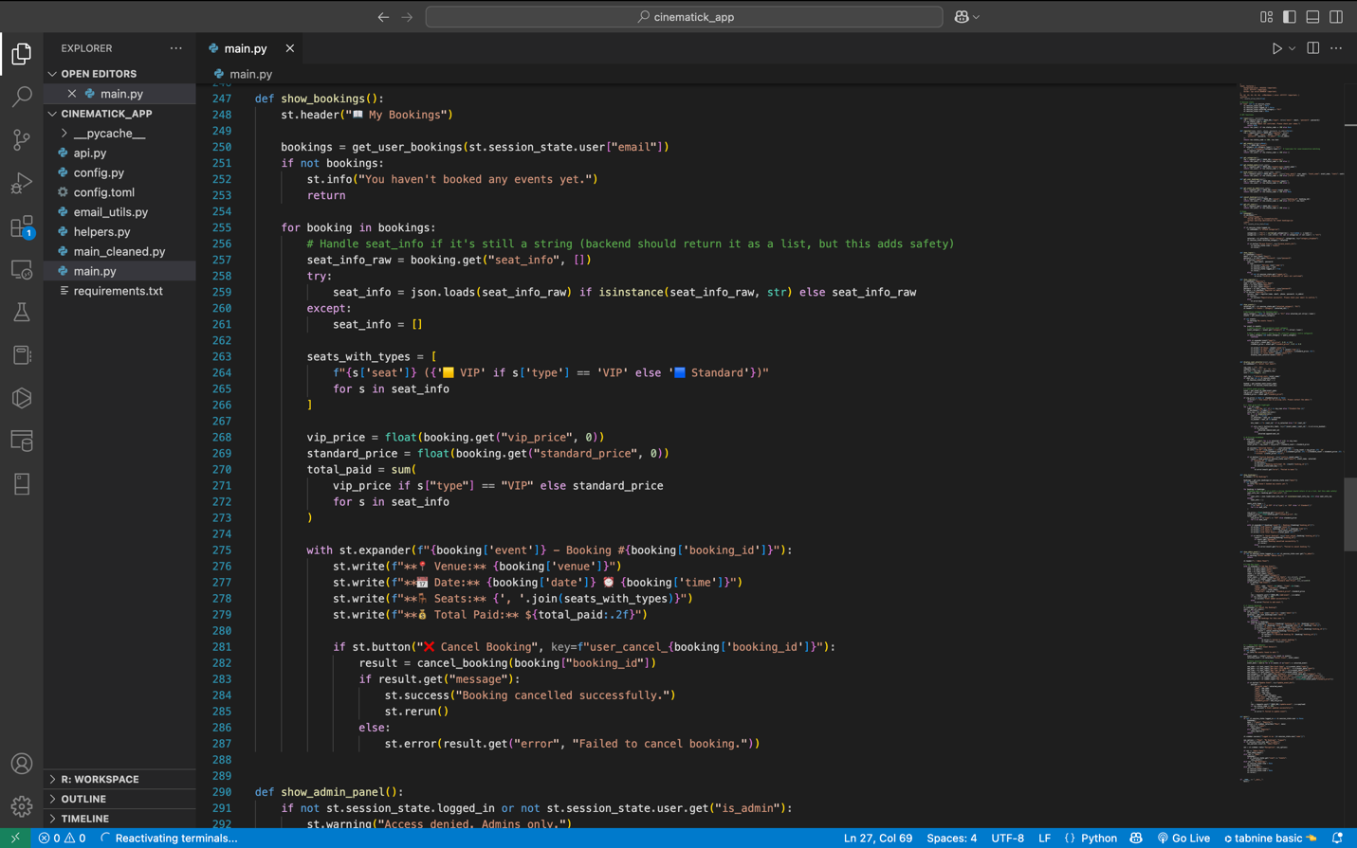

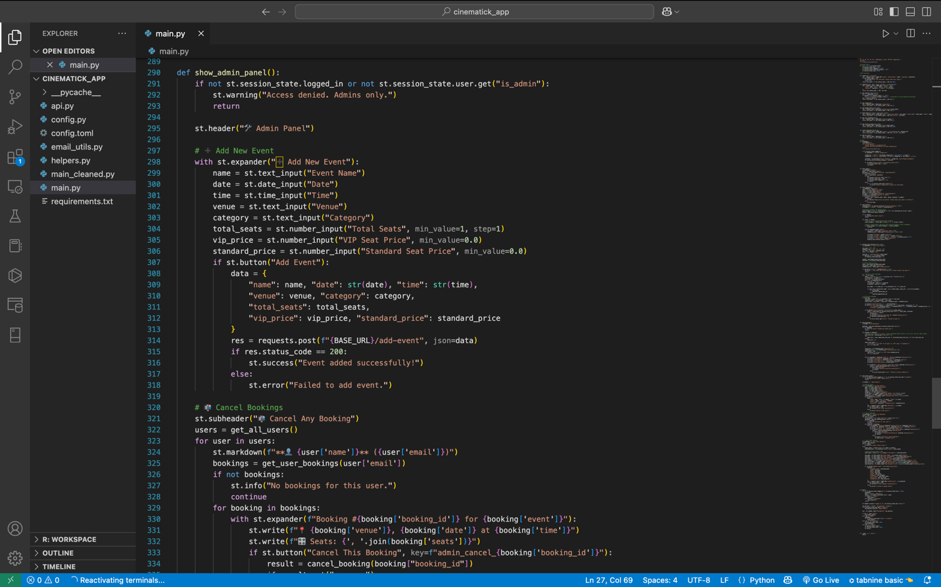

In short, the Streamlit app provides the visual interaction layer that abstracts the graph database complexity for users and administrators. It leverages REST APIs to read and write data into the Neo4j database, ensuring real-time updates, relationship management, and accurate transactional flows between users, bookings, and events.

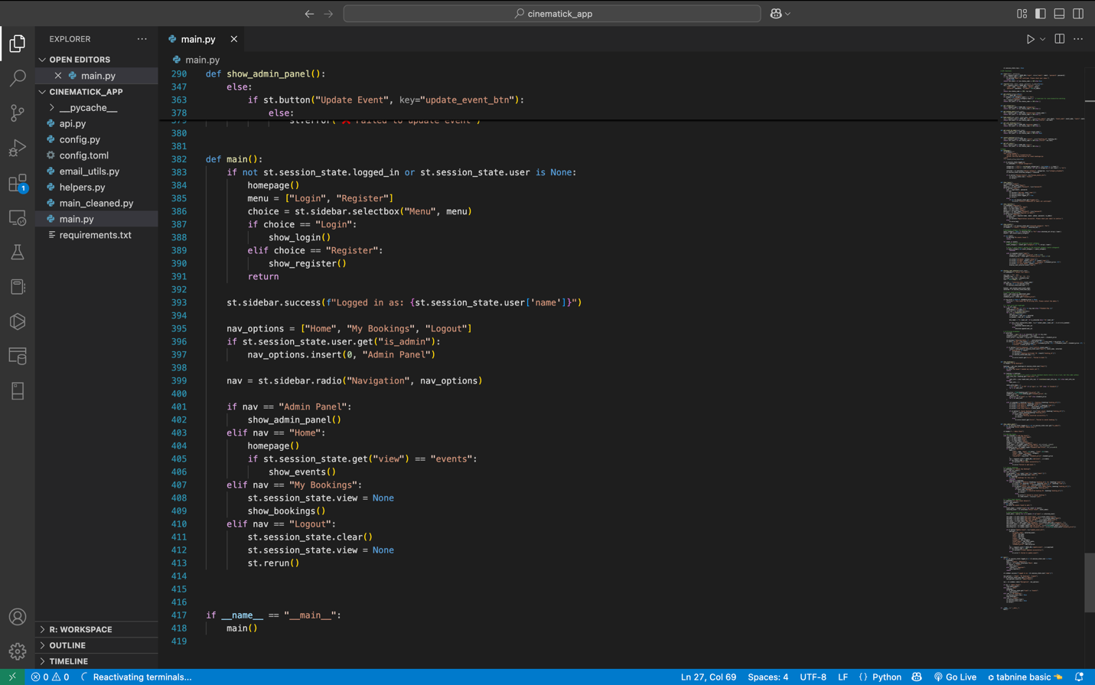

**email_utils.py**

This Python module handles email notification integration within the CinemaTick event booking system and, while it doesn’t directly interact with the Neo4j database, it plays a vital role in enhancing the transactional integrity and user experience surrounding database-driven operations. The core functionality lies in sending confirmation and cancellation emails after a booking-related action is committed in the database. Specifically, when a BOOKED relationship is created between a User and an Event node in Neo4j (reflecting a confirmed booking), the send_email_with_qr() function is invoked. It generates a QR code that encodes booking details (booking ID, event name, and selected seats) and sends it as an email attachment using the SendGrid API. This QR code acts as a verifiable external token tied to the internal booking record in the graph database.

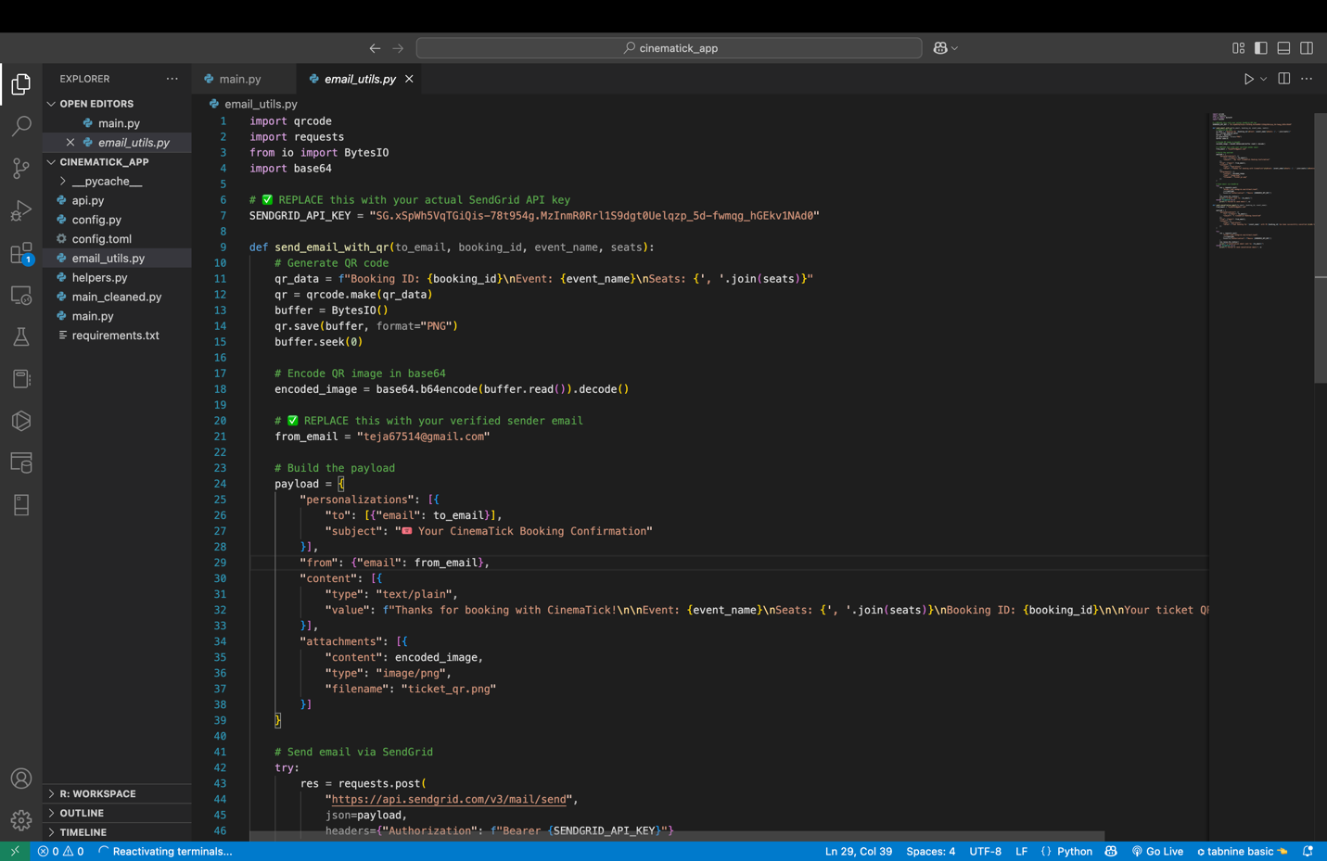

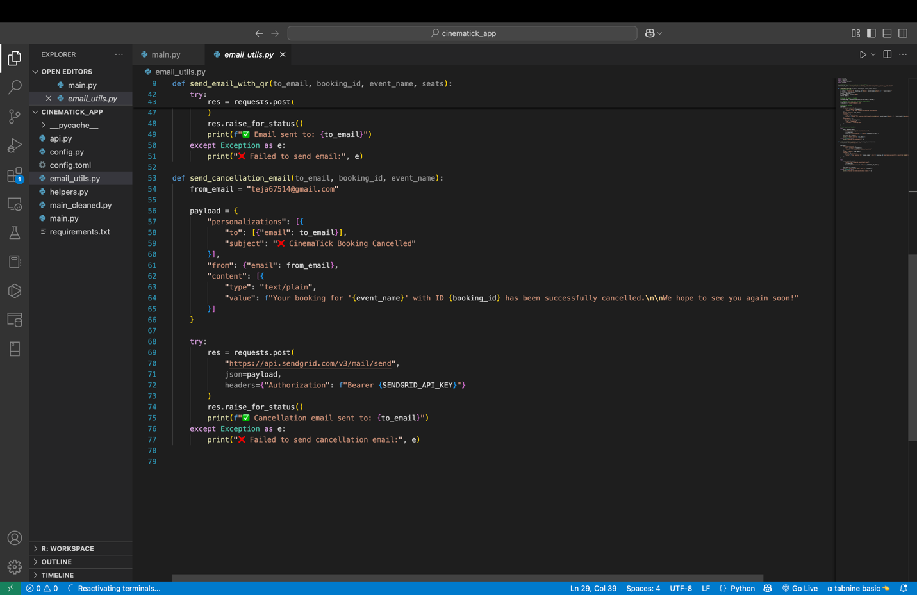

Similarly, when a BOOKED relationship is deleted due to booking cancellation, the send_cancellation_email() function is triggered to notify the user. While the database manages persistent state (nodes and relationships), these email functions ensure real-time external communication that aligns with the database’s state transitions. They maintain synchronization between user-facing communications and database transactions, reinforcing reliability, traceability, and auditability within the system. This approach complements the graph-based database model by extending its transactional visibility into the user’s inbox, thus enriching the booking lifecycle beyond the database layer.

**helpers.py**

This Streamlit-based user interface forms a key part of the CinemaTick system, enabling real-time interaction with a Neo4j graph database through backend APIs. Although it doesn't directly query the database, this frontend orchestrates user operations such as login, registration, seat selection, event creation, and booking management—all of which result in updates to the graph database via the FastAPI backend. The UI communicates with Neo4j indirectly by invoking endpoints that manipulate graph nodes like User, Event, Venue, and Category, and relationships like BOOKED.

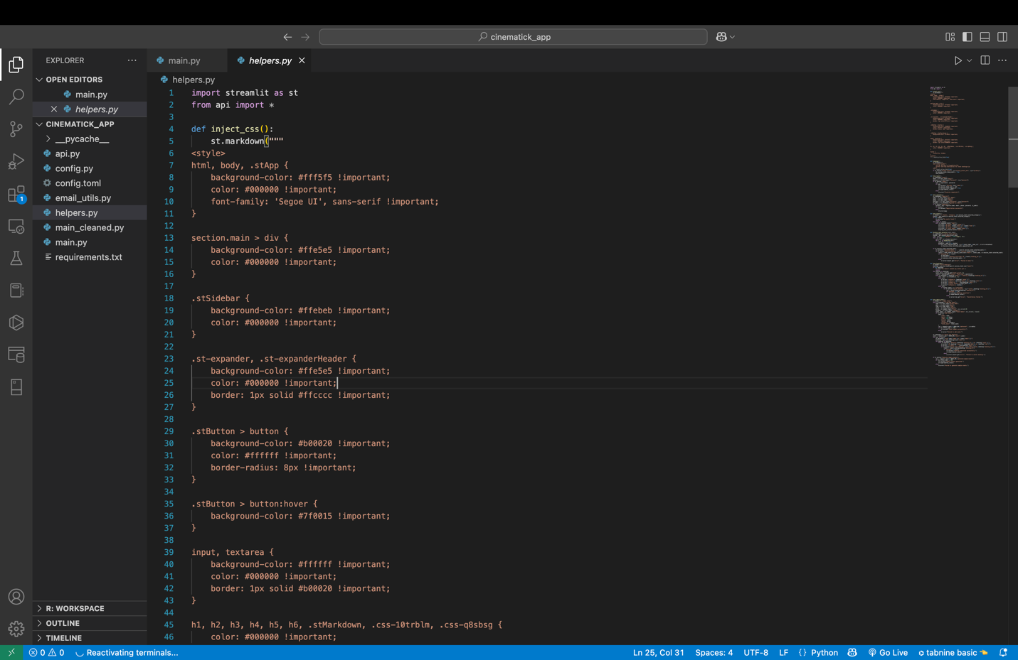

For example, when a user selects seats for an event and confirms a booking, the frontend sends this data to the backend, which in turn creates a BOOKED relationship between the User and Event nodes, embedding booking metadata (seats, types, timestamp). Admin functionalities, such as adding or cancelling events and bookings, trigger creation or deletion of Event nodes and their connected Venue and Category nodes or BOOKED relationships.

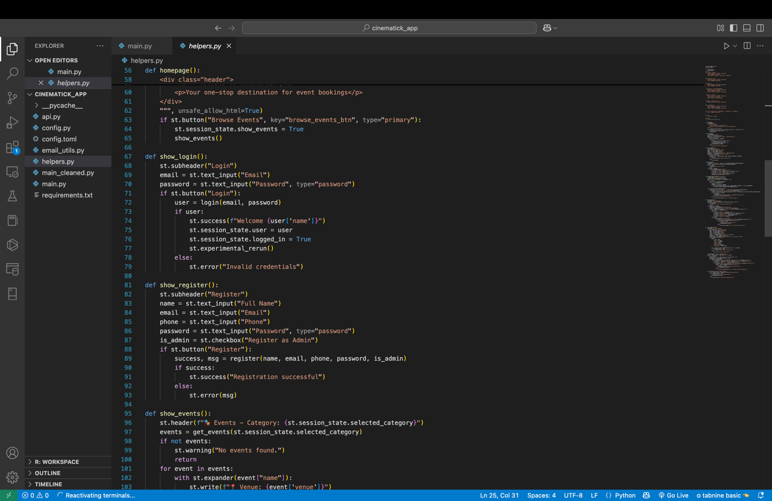

The frontend ensures all components remain in sync with the database structure: bookings are listed by reading BOOKED relationships, available seats are computed by querying booked nodes, and dynamic UI states reflect the database's current snapshot. While it doesn't interact with Neo4j directly, the interface is tightly coupled with the graph schema, ensuring that every visual operation corresponds to a graph-level action, maintaining both data consistency and traceability.

**api.py**

This Python module acts as an API client layer for the CinemaTick application, facilitating communication between the frontend and the Neo4j graph database via the FastAPI backend. Although it does not directly perform database operations itself, it plays a crucial role in abstracting and triggering graph database modifications. Every function in this module (e.g., login, register, book_event) corresponds to a specific backend endpoint that ultimately reads from or writes to the graph database.

When a user logs in or registers, User nodes in Neo4j are queried or created. Retrieving event listings (get_events), categories (get_categories), and booked seats (get_booked_seats) involves traversing the graph structure, fetching Event, Category, and BOOKED relationship data. Booking an event (book_event) leads to the creation of a BOOKED relationship between a User node and an Event node, storing booking metadata like seat numbers and types. Cancelling a booking (cancel_booking) results in the deletion of such a relationship, maintaining database consistency.

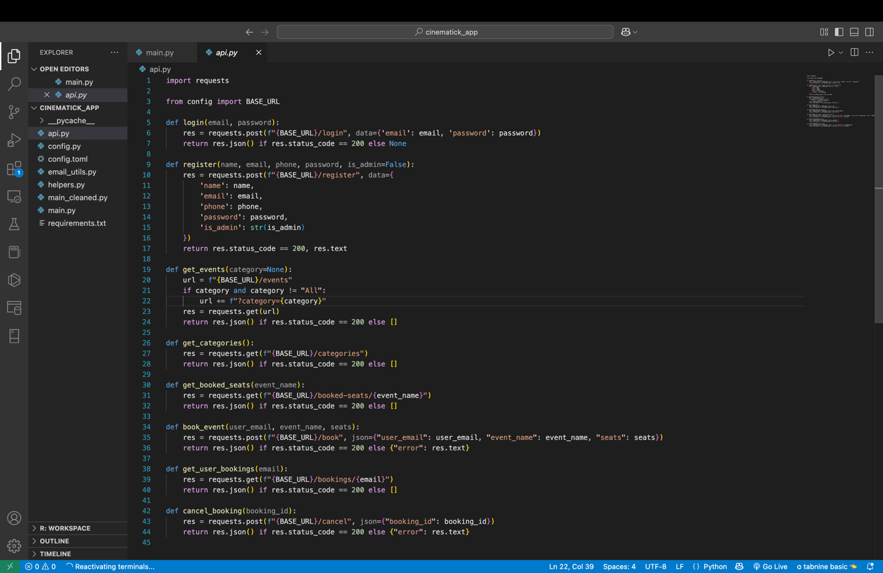

In essence, this module maps user interface actions to graph database operations through a RESTful service, ensuring that user-initiated events lead to real-time updates in the underlying Neo4j database without the frontend needing direct knowledge of the graph's structure.

**Key Features Highlight**

* Graph Database Usage:
* Neo4j efficiently handles relationships among users, events, and venues.
* Optimized queries allow fast event and booking management.
* Email Notifications:
* Real-time ticket confirmation and cancellation communication.
* QR codes simplify event entry and enhance security.
* Real-Time Seat Booking:
* Dynamic seat availability updated after every booking.
* Admin Management:
* Comprehensive event and booking control for admins.

**Future Enhancements**

* Implement payment gateway integration (e.g., Stripe, PayPal).
* Generate printable tickets.
* Introduce event reviews and ratings.
* Add multilingual support for wider audience reach.
* Extend user authentication to social logins (Google, Facebook).

**Conclusion:**

The CinemaTick Event Booking System successfully demonstrates the power of integrating a graph database (Neo4j) with a modern web-based frontend (Streamlit) and a RESTful backend (FastAPI). By representing users, events, venues, and bookings as interconnected nodes and relationships, the system efficiently handles complex queries like seat availability, event categorization, and user bookings in real time. The platform provides a seamless experience for both users and administrators, supporting features like registration, event browsing, real-time seat selection, booking management, and cancellation, all synchronized with database operations. The use of email notifications with QR code attachments further enhances the system’s professionalism and user trust.

CinemaTick effectively showcases how graph databases outperform traditional relational models in managing highly connected data scenarios like event management. The system’s modular design, API-driven architecture, and real-time database interaction ensure scalability, flexibility, and ease of maintenance. Overall, CinemaTick achieves its goal of creating a robust, intuitive, and future-ready event ticketing platform.